ultramirinc.champs_mood

Class FriendProfileActivity

java.lang.Object

android.content.Context

android.content.ContextWrapper

android.view.ContextThemeWrapper

android.app.Activity

android.support.v4.app.SupportActivity

android.support.v4.app.FragmentActivity

android.support.v7.app.AppCompatActivity ultramirinc.champs_mood.FriendProfileActivity

All Implemented Interfaces:

android.content.ComponentCallbacks, android.content.ComponentCallbacks2, android.support.v4.app.ActivityCompat.OnRequestPermissionsResultCallback, android.support.v4.app.ActivityCompatApi23.RequestPermissionsRequestCodeValidator, android.support.v4.app.TaskStackBuilder.SupportParentable, android.support.v7.app.ActionBarDrawerToggle.DelegateProvider, android.support.v7.app.AppCompatCallback, android.view.KeyEvent.Callback, android.view.LayoutInflater.Factory, android.view.LayoutInflater.Factory2, android.view.View.OnCreateContextMenuListener, android.view.Window.Callback, com.google.android.gms.maps.OnMapReadyCallback



public class FriendProfileActivity

extends android.support.v7.app.AppCompatActivity implements com.google.android.gms.maps.OnMapReadyCallback

Created by Etienne Berube on 2017­05­05. This is the profile of a given user (That is the the current user). This allows the user to see his friend's profile and location



*Nested Class Summary*

Nested classes/interfaces inherited from class android.support.v4.app.SupportActivity

android.support.v4.app.SupportActivity.ExtraData

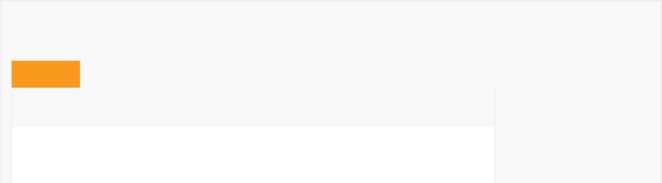

*Field Summary*

Fields

|  |  |
| --- | --- |
| Modifier and Type | Field and |
|  | Description |

private User friendProfile

Contains the friend's User object



private com.google.android.gms.maps.model.LatLng latLng

|  |  |
| --- | --- |
|  | Contains the |
|  | friend's |
|  | location |
| private com.google.android.gms.maps.GoogleMap | mMap |
|  | Contains the |
|  | map used |
|  |  |
| private android.app.ProgressDialog | progressDialog |
|  | Contains a |
|  | progress dialog |
|  |  |

Fields inherited from class android.app.Activity

DEFAULT_KEYS_DIALER, DEFAULT_KEYS_DISABLE, DEFAULT_KEYS_SEARCH_GLOBAL,

DEFAULT_KEYS_SEARCH_LOCAL, DEFAULT_KEYS_SHORTCUT, FOCUSED_STATE_SET,

RESULT_CANCELED, RESULT_FIRST_USER, RESULT_OK

Fields inherited from class android.content.Context

ACCESSIBILITY_SERVICE, ACCOUNT_SERVICE, ACTIVITY_SERVICE, ALARM_SERVICE,

APP_OPS_SERVICE, APPWIDGET_SERVICE, AUDIO_SERVICE, BATTERY_SERVICE,

BIND_ABOVE_CLIENT, BIND_ADJUST_WITH_ACTIVITY, BIND_ALLOW_OOM_MANAGEMENT,

BIND_AUTO_CREATE, BIND_DEBUG_UNBIND, BIND_EXTERNAL_SERVICE, BIND_IMPORTANT,

BIND_NOT_FOREGROUND, BIND_WAIVE_PRIORITY, BLUETOOTH_SERVICE, CAMERA_SERVICE,

CAPTIONING_SERVICE, CARRIER_CONFIG_SERVICE, CLIPBOARD_SERVICE,

CONNECTIVITY_SERVICE, CONSUMER_IR_SERVICE, CONTEXT_IGNORE_SECURITY,

CONTEXT_INCLUDE_CODE, CONTEXT_RESTRICTED, DEVICE_POLICY_SERVICE, DISPLAY_SERVICE,

DOWNLOAD_SERVICE, DROPBOX_SERVICE, FINGERPRINT_SERVICE,

HARDWARE_PROPERTIES_SERVICE, INPUT_METHOD_SERVICE, INPUT_SERVICE,

JOB_SCHEDULER_SERVICE, KEYGUARD_SERVICE, LAUNCHER_APPS_SERVICE,

LAYOUT_INFLATER_SERVICE, LOCATION_SERVICE, MEDIA_PROJECTION_SERVICE,

MEDIA_ROUTER_SERVICE, MEDIA_SESSION_SERVICE, MIDI_SERVICE, MODE_APPEND,

MODE_ENABLE_WRITE_AHEAD_LOGGING, MODE_MULTI_PROCESS, MODE_NO_LOCALIZED_COLLATORS,

MODE_PRIVATE, MODE_WORLD_READABLE, MODE_WORLD_WRITEABLE, NETWORK_STATS_SERVICE,

NFC_SERVICE, NOTIFICATION_SERVICE, NSD_SERVICE, POWER_SERVICE, PRINT_SERVICE,

RESTRICTIONS_SERVICE, SEARCH_SERVICE, SENSOR_SERVICE, SHORTCUT_SERVICE,

STORAGE_SERVICE, SYSTEM_HEALTH_SERVICE, TELECOM_SERVICE, TELEPHONY_SERVICE,

TELEPHONY_SUBSCRIPTION_SERVICE, TEXT_SERVICES_MANAGER_SERVICE, TV_INPUT_SERVICE,

UI_MODE_SERVICE, USAGE_STATS_SERVICE, USB_SERVICE, USER_SERVICE, VIBRATOR_SERVICE,

WALLPAPER_SERVICE, WIFI_P2P_SERVICE, WIFI_SERVICE, WINDOW_SERVICE

Fields inherited from interface android.content.ComponentCallbacks2

TRIM_MEMORY_BACKGROUND, TRIM_MEMORY_COMPLETE, TRIM_MEMORY_MODERATE,

TRIM_MEMORY_RUNNING_CRITICAL, TRIM_MEMORY_RUNNING_LOW,

TRIM_MEMORY_RUNNING_MODERATE, TRIM_MEMORY_UI_HIDDEN

*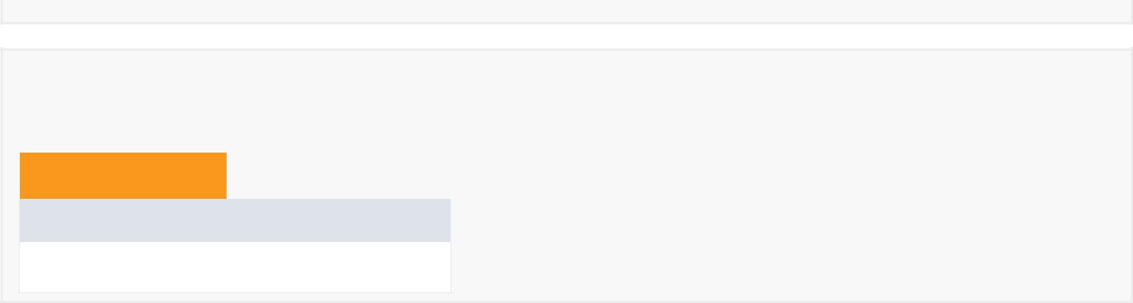Constructor Summary*

Constructors

Constructor and Description

FriendProfileActivity()



|  |  |  |  |  |  |  |  |  |  |  |
| --- | --- | --- | --- | --- | --- | --- | --- | --- | --- | --- |
| *Method Summary* | | | | | |  |  |  |  |  |
|  |  | |  |  |  |  |  |  |  |  |
|  | All Methods |  |  | [Static Methods](javascript:show(1);) |  | [Instance Methods](javascript:show(2);) |  |  | [Concrete Methods](javascript:show(8);) |  |
|  | Modifier and Type | | | Method and Description | | | | |  |  |
|  | private int | | | adaptDayOfWeek(int weekday) | | | | |  |  |
|  |  |  |  | There is a mismatch between our original int values of weekdays with | | | | | | |
|  |  |  |  | the java.utils.calendar int values of weekdays. | | | | |  |  |
|  |  |  |  |  |  | |  |  |  |  |
|  | private void | | | checkBreakStatus() | | | | |  |  |
|  |  |  |  | Checks the status of the friend's break (in break in X minutes, in break | | | | | | |
|  |  |  |  | or no more breaks). | |  |  |  |  |  |
|  | private void | | | follow(User userToFollow) | | | | |  |  |
|  |  |  |  | Allows to follow the given user. | | | | |  |  |
|  |  |  |  |  |  | |  |  | |  |
|  | static long | | | getDateDiff(java.util.GregorianCalendar date1, | | | | | | |
|  |  |  |  | java.util.GregorianCalendar date2, | | | | |  |  |
|  |  |  |  | java.util.concurrent.TimeUnit timeUnit) | | | | | | |
|  |  |  |  | Returns the time difference in milliseconds between two dates. | | | | | | |
|  | void | | | loadFriendProfile(java.lang.String userId) | | | | | | |
|  |  |  |  | Gets the user's information from the database. | | | | |  |  |
|  |  |  |  |  |  |  |  |  |  |  |
|  | void | | | onBackPressed() | |  |  |  |  |  |
|  |  |  |  | Handles the event when the back button is pressed on the android | | | | | | |
|  |  |  |  | device. | |  |  |  |  |  |
|  | protected void | | | onCreate(android.os.Bundle savedInstanceState) | | | | | | |
|  |  |  |  | Creates and inflates the layout of the activity. | | | | |  |  |
|  |  |  |  |  |  | |  |  | |  |
|  | void | | | onMapReady(com.google.android.gms.maps.GoogleMap googleMap) | | | | | | |
|  |  |  |  | Sets the map when it is ready (Location, zoom, position, markers, etc.). | | | | | | |
|  | private boolean | | | unFollow(User userToUnfollow) | | | | |  |  |
|  |  |  |  | Allows to unfollow the given user. | | | | |  |  |
|  |  |  |  |  |  | |  |  | |  |
|  | void | | | updateFriendShipButton(boolean isFriend) | | | | | | |
|  |  |  |  | Updates the text of the button. | | | | |  |  |
|  |  |  |  |  |  |  |  |  |  |  |

Methods inherited from class android.support.v7.app.AppCompatActivity

addContentView, dispatchKeyEvent, findViewById, getDelegate, getDrawerToggleDelegate, getMenuInflater, getResources, getSupportActionBar, getSupportParentActivityIntent, invalidateOptionsMenu, onConfigurationChanged, onContentChanged, onCreateSupportNavigateUpTaskStack, onDestroy, onMenuItemSelected, onMenuOpened, onPanelClosed, onPostCreate, onPostResume, onPrepareSupportNavigateUpTaskStack, onSaveInstanceState, onStart, onStop, onSupportActionModeFinished, onSupportActionModeStarted, onSupportContentChanged, onSupportNavigateUp, onTitleChanged, onWindowStartingSupportActionMode, setContentView, setContentView, setContentView, setSupportActionBar, setSupportProgress, setSupportProgressBarIndeterminate, setSupportProgressBarIndeterminateVisibility, setSupportProgressBarVisibility, setTheme, startSupportActionMode, supportInvalidateOptionsMenu, supportNavigateUpTo, supportRequestWindowFeature, supportShouldUpRecreateTask



Methods inherited from class android.support.v4.app.FragmentActivity

dump, getLastCustomNonConfigurationInstance, getSupportFragmentManager, getSupportLoaderManager, getSupportMediaController, onActivityResult, onAttachFragment, onCreatePanelMenu, onLowMemory, onMultiWindowModeChanged, onNewIntent, onPause, onPictureInPictureModeChanged, onPrepareOptionsPanel, onPreparePanel, onRequestPermissionsResult, onResume, onResumeFragments, onRetainCustomNonConfigurationInstance, onRetainNonConfigurationInstance, onStateNotSaved, setEnterSharedElementCallback, setExitSharedElementCallback, setSupportMediaController, startActivityForResult, startActivityFromFragment, startActivityFromFragment, startIntentSenderFromFragment, supportFinishAfterTransition, supportPostponeEnterTransition, supportStartPostponedEnterTransition, validateRequestPermissionsRequestCode

Methods inherited from class android.support.v4.app.SupportActivity

getExtraData, putExtraData

Methods inherited from class android.app.Activity

closeContextMenu, closeOptionsMenu, createPendingResult, dismissDialog, dismissKeyboardShortcutsHelper, dispatchGenericMotionEvent, dispatchKeyShortcutEvent, dispatchPopulateAccessibilityEvent, dispatchTouchEvent, dispatchTrackballEvent, enterPictureInPictureMode, finish, finishActivity, finishActivityFromChild, finishAffinity, finishAfterTransition, finishAndRemoveTask, finishFromChild, getActionBar, getApplication, getCallingActivity, getCallingPackage, getChangingConfigurations, getComponentName, getContentScene, getContentTransitionManager, getCurrentFocus, getFragmentManager, getIntent, getLastNonConfigurationInstance, getLayoutInflater, getLoaderManager, getLocalClassName, getMediaController, getParent, getParentActivityIntent, getPreferences, getReferrer, getRequestedOrientation, getSearchEvent, getSystemService, getTaskId, getTitle, getTitleColor, getVoiceInteractor, getVolumeControlStream, getWindow, getWindowManager, hasWindowFocus, isChangingConfigurations, isChild, isDestroyed, isFinishing, isImmersive, isInMultiWindowMode, isInPictureInPictureMode, isLocalVoiceInteractionSupported, isTaskRoot, isVoiceInteraction, isVoiceInteractionRoot, managedQuery,

moveTaskToBack, navigateUpTo, navigateUpToFromChild, onActionModeFinished, onActionModeStarted, onActivityReenter, onApplyThemeResource, onAttachedToWindow, onAttachFragment, onChildTitleChanged, onContextItemSelected, onContextMenuClosed, onCreate, onCreateContextMenu, onCreateDescription, onCreateDialog, onCreateDialog, onCreateNavigateUpTaskStack, onCreateOptionsMenu, onCreatePanelView, onCreateThumbnail, onDetachedFromWindow, onEnterAnimationComplete, onGenericMotionEvent, onKeyDown, onKeyLongPress, onKeyMultiple, onKeyShortcut, onKeyUp, onLocalVoiceInteractionStarted, onLocalVoiceInteractionStopped, onNavigateUp, onNavigateUpFromChild, onOptionsItemSelected, onOptionsMenuClosed, onPostCreate, onPrepareDialog, onPrepareDialog, onPrepareNavigateUpTaskStack, onPrepareOptionsMenu, onProvideAssistContent, onProvideAssistData, onProvideKeyboardShortcuts, onProvideReferrer, onRestart, onRestoreInstanceState, onRestoreInstanceState, onSaveInstanceState, onSearchRequested, onSearchRequested, onTouchEvent, onTrackballEvent, onTrimMemory, onUserInteraction, onUserLeaveHint, onVisibleBehindCanceled, onWindowAttributesChanged, onWindowFocusChanged, onWindowStartingActionMode, onWindowStartingActionMode, openContextMenu, openOptionsMenu, overridePendingTransition, postponeEnterTransition, recreate, registerForContextMenu, releaseInstance, removeDialog, reportFullyDrawn, requestDragAndDropPermissions, requestPermissions, requestShowKeyboardShortcuts, requestVisibleBehind, requestWindowFeature, runOnUiThread, setActionBar, setContentTransitionManager, setDefaultKeyMode, setEnterSharedElementCallback, setExitSharedElementCallback, setFeatureDrawable, setFeatureDrawableAlpha, setFeatureDrawableResource, setFeatureDrawableUri, setFinishOnTouchOutside, setImmersive, setIntent, setMediaController, setProgress, setProgressBarIndeterminate, setProgressBarIndeterminateVisibility, setProgressBarVisibility, setRequestedOrientation, setResult, setResult, setSecondaryProgress, setTaskDescription, setTitle, setTitle, setTitleColor, setVisible, setVolumeControlStream, setVrModeEnabled, shouldShowRequestPermissionRationale, shouldUpRecreateTask, showAssist, showDialog, showDialog, showLockTaskEscapeMessage, startActionMode, startActionMode, startActivities, startActivities, startActivity, startActivity, startActivityFromChild, startActivityFromChild, startActivityFromFragment, startActivityFromFragment, startActivityIfNeeded, startActivityIfNeeded, startIntentSender, startIntentSender, startIntentSenderFromChild, startIntentSenderFromChild, startLocalVoiceInteraction, startLockTask, startManagingCursor, startNextMatchingActivity, startNextMatchingActivity, startPostponedEnterTransition, startSearch, stopLocalVoiceInteraction, stopLockTask, stopManagingCursor, takeKeyEvents, triggerSearch, unregisterForContextMenu



Methods inherited from class android.view.ContextThemeWrapper

applyOverrideConfiguration, attachBaseContext, getAssets, getTheme

Methods inherited from class android.content.ContextWrapper

bindService, checkCallingOrSelfPermission, checkCallingOrSelfUriPermission, checkCallingPermission, checkCallingUriPermission, checkPermission, checkSelfPermission, checkUriPermission, checkUriPermission, clearWallpaper, createConfigurationContext, createDeviceProtectedStorageContext,

createDisplayContext, createPackageContext, databaseList, deleteDatabase, deleteFile, deleteSharedPreferences, enforceCallingOrSelfPermission, enforceCallingOrSelfUriPermission, enforceCallingPermission, enforceCallingUriPermission, enforcePermission, enforceUriPermission, enforceUriPermission, fileList, getApplicationContext, getApplicationInfo, getBaseContext, getCacheDir, getClassLoader, getCodeCacheDir, getContentResolver, getDatabasePath, getDataDir, getDir, getExternalCacheDir, getExternalCacheDirs, getExternalFilesDir, getExternalFilesDirs, getExternalMediaDirs, getFilesDir, getFileStreamPath, getMainLooper, getNoBackupFilesDir, getObbDir, getObbDirs, getPackageCodePath, getPackageManager, getPackageName, getPackageResourcePath, getSharedPreferences, getSystemServiceName, getWallpaper, getWallpaperDesiredMinimumHeight, getWallpaperDesiredMinimumWidth, grantUriPermission, isDeviceProtectedStorage, isRestricted, moveDatabaseFrom, moveSharedPreferencesFrom, openFileInput, openFileOutput, openOrCreateDatabase, openOrCreateDatabase, peekWallpaper, registerReceiver, registerReceiver, removeStickyBroadcast, removeStickyBroadcastAsUser, revokeUriPermission, sendBroadcast, sendBroadcast, sendBroadcastAsUser, sendBroadcastAsUser, sendOrderedBroadcast, sendOrderedBroadcast, sendOrderedBroadcastAsUser, sendStickyBroadcast, sendStickyBroadcastAsUser, sendStickyOrderedBroadcast, sendStickyOrderedBroadcastAsUser, setWallpaper, setWallpaper, startInstrumentation, startService, stopService, unbindService, unregisterReceiver

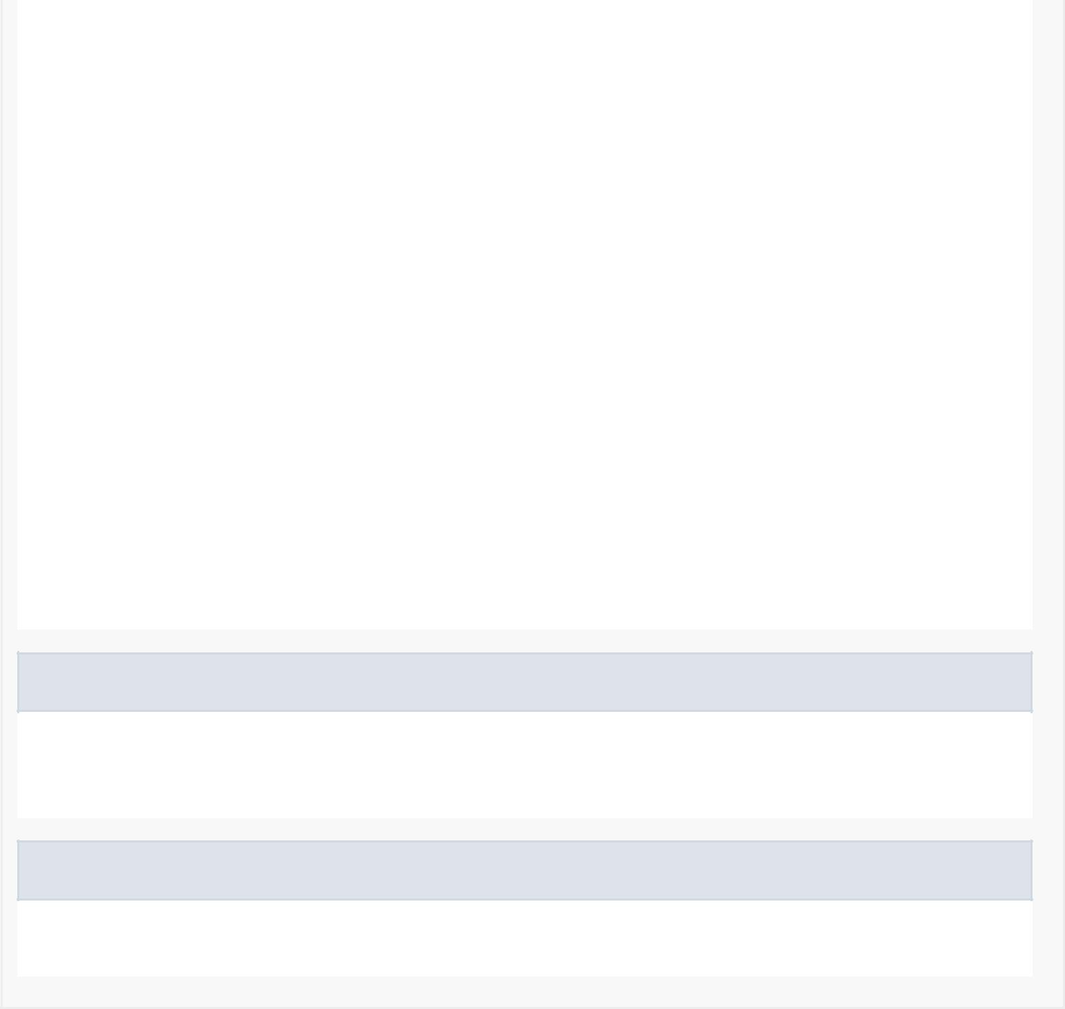

Methods inherited from class android.content.Context

getColor, getColorStateList, getDrawable, getString, getString, getSystemService, getText, obtainStyledAttributes, obtainStyledAttributes, obtainStyledAttributes, obtainStyledAttributes, registerComponentCallbacks, unregisterComponentCallbacks

Methods inherited from class java.lang.Object

clone, equals, finalize, getClass, hashCode, notify, notifyAll, toString, wait, wait, wait



*Field Detail*

mMap

private com.google.android.gms.maps.GoogleMap mMap

Contains the map used

friendProfile

private User friendProfile

Contains the friend's User object

latLng

private com.google.android.gms.maps.model.LatLng latLng

Contains the friend's location

progressDialog

private android.app.ProgressDialog progressDialog

Contains a progress dialog

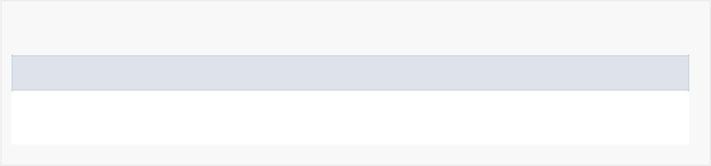

*Constructor Detail*

FriendProfileActivity

public FriendProfileActivity()



*Method Detail*

onCreate

protected void onCreate(android.os.Bundle savedInstanceState)

Creates and inflates the layout of the activity.

Overrides:

onCreate in class android.support.v7.app.AppCompatActivity

loadFriendProfile

public void loadFriendProfile(java.lang.String userId)

Gets the user's information from the database.

unFollow

private boolean unFollow(User userToUnfollow)

Allows to unfollow the given user.

follow

private void follow(User userToFollow)



Allows to follow the given user.

updateFriendShipButton

public void updateFriendShipButton(boolean isFriend)

Updates the text of the button.

checkBreakStatus

private void checkBreakStatus()

Checks the status of the friend's break (in break in X minutes, in break or no more breaks).

adaptDayOfWeek

private int adaptDayOfWeek(int weekday)

There is a mismatch between our original int values of weekdays with the java.utils.calendar int values of weekdays.

getDateDiff

public static long getDateDiff(java.util.GregorianCalendar date1, java.util.GregorianCalendar date2, java.util.concurrent.TimeUnit timeUnit)

Returns the time difference in milliseconds between two dates.

onMapReady

public void onMapReady(com.google.android.gms.maps.GoogleMap googleMap)

Sets the map when it is ready (Location, zoom, position, markers, etc.).

Specified by:

onMapReady in interface com.google.android.gms.maps.OnMapReadyCallback

onBackPressed

public void onBackPressed()

Handles the event when the back button is pressed on the android device.

Overrides:

onBackPressed in class android.support.v4.app.FragmentActivity

